Assignment - 1

Name: N. Sushanth Reddy
Roll Number: 2303A51118
Batch - 03
AI Assisted Coding
07-01-2026
Task 0: Environment Setup:-
Task 0
● Install and configure GitHub Copilot in VS Code. Take screenshots of
each step.
Expected Output
● Install and configure GitHub Copilot in VS Code. Take screenshots of
each step.
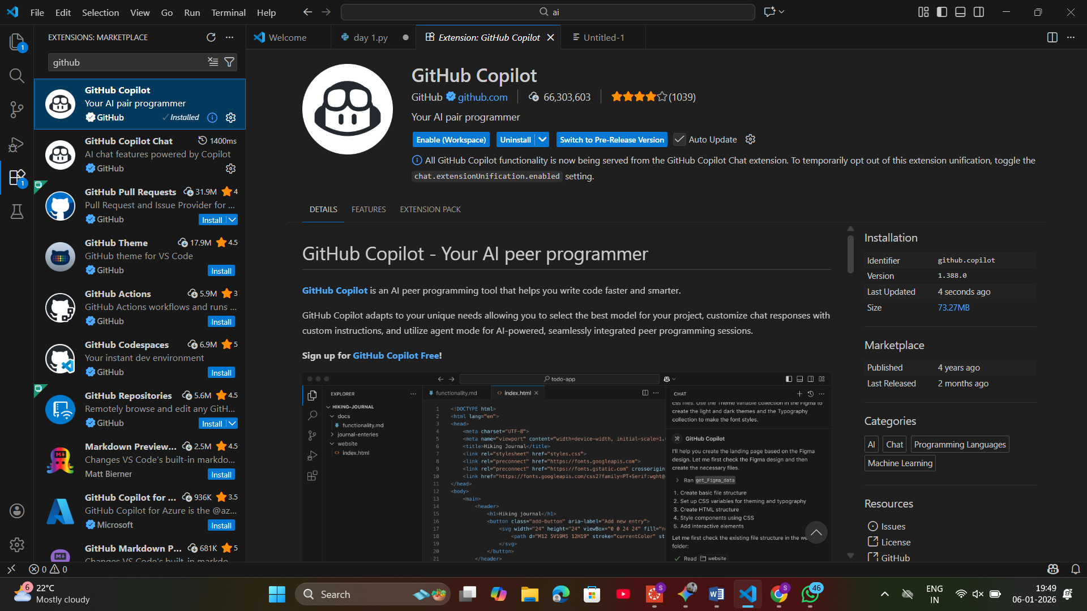
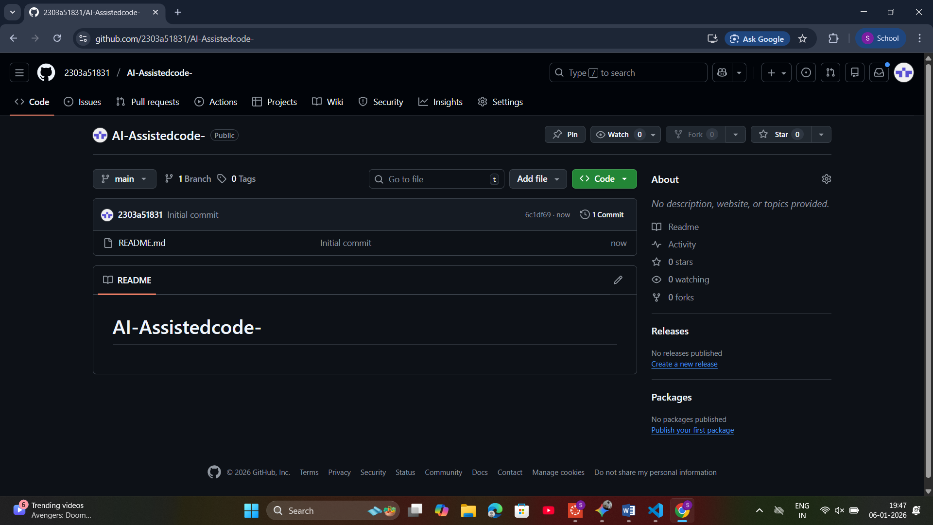
Task 1: Non-Modular Logic (Factorial):-
AI-Generated Logic Without Modularization (Factorial without
Functions)
• Scenario
You are building a small command-line utility for a startup intern onboarding
task. The program is simple and must be written quickly without modular
design.
• Task Description
Use GitHub Copilot to generate a Python program that computes a
mathematical product-based value (factorial-like logic) directly in the main
execution flow, without using any user-defined functions.
• Constraint:
➢ Do not define any custom function
➢ Logic must be implemented using loops and variables only
• Expected Deliverables
➢ A working Python program generated with Copilot assistance
➢ Screenshot(s) showing:
➢ The prompt you typed
➢ Copilot’s suggestions
➢ Sample input/output screenshots
➢ Brief reflection (5–6 lines):
➢ How helpful was Copilot for a beginner?
➢ Did it follow best practices automatically?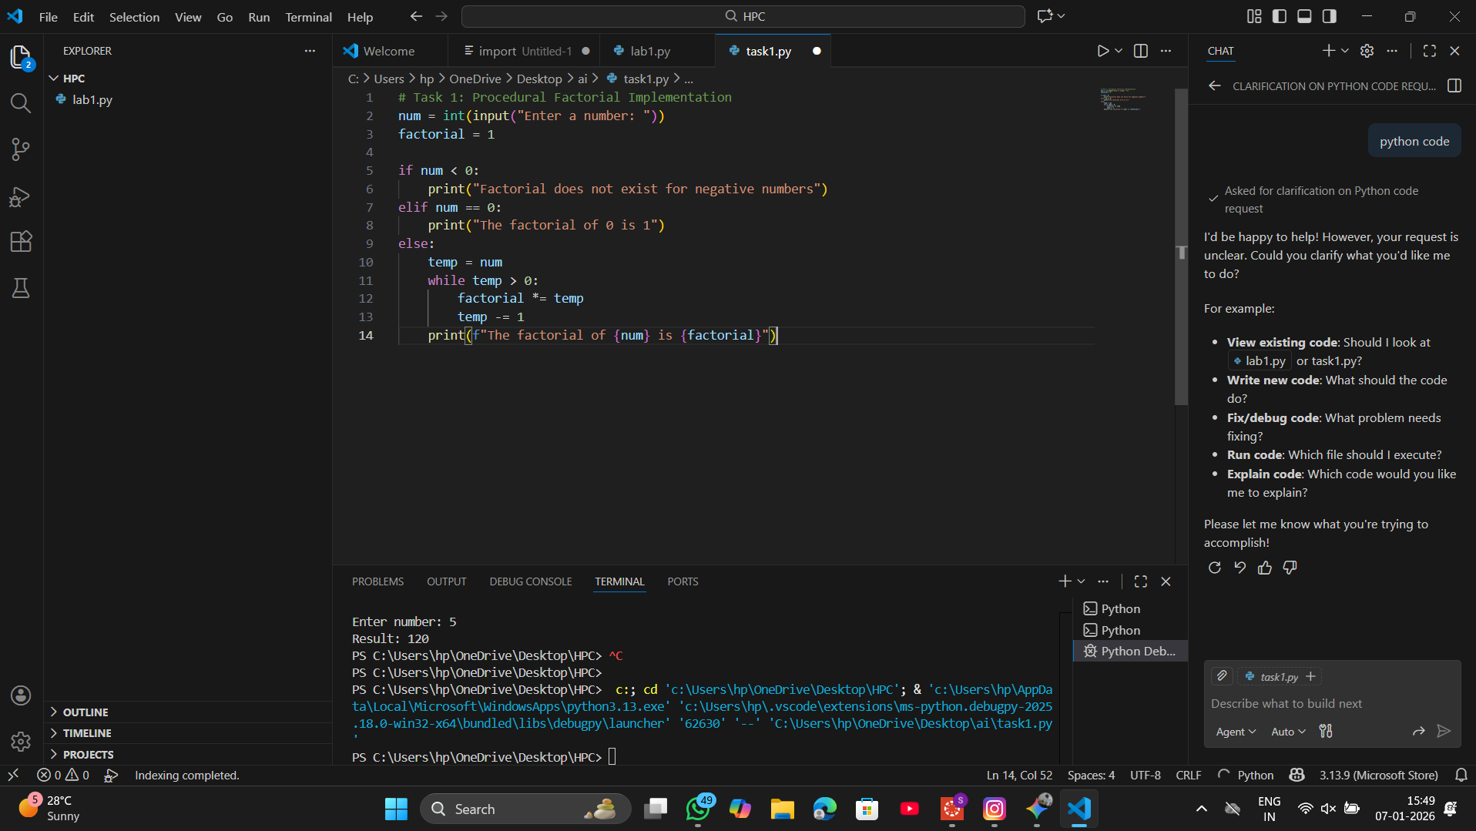
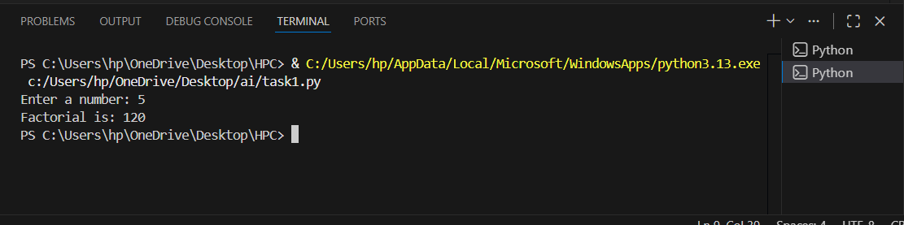
Task 2: AI Code Optimization:-
AI Code Optimization & Cleanup (Improving Efficiency)
❖ Scenario
Your team lead asks you to review AI-generated code before committing it to
a shared repository.
❖ Task Description
Analyze the code generated in Task 1 and use Copilot again to:
➢ Reduce unnecessary variables
➢ Improve loop clarity
➢ Enhance readability and efficiency
Hint:
Prompt Copilot with phrases like
“optimize this code”, “simplify logic”, or “make it more readable”
❖ Expected Deliverables
➢ Original AI-generated code
➢ Optimized version of the same code
➢ Side-by-side comparison
➢ Written explanation:
▪ What was improved?
▪ Why the new version is better (readability, performance,
maintainability.
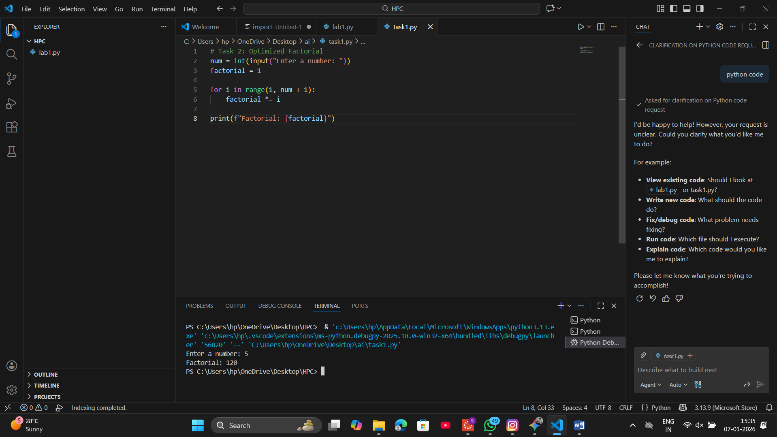
Task 3: Modular Design Using AI Assistance (Factorial with Functions)
❖ Scenario
The same logic now needs to be reused in multiple scripts.
❖ Task Description
Use GitHub Copilot to generate a modular version of the program by:
➢ Creating a user-defined function
➢ Calling the function from the main block
❖ Constraints
➢ Use meaningful function and variable names
➢ Include inline comments (preferably suggested by Copilot)
❖ Expected Deliverables
➢ AI-assisted function-based program
➢ Screenshots showing:
o Prompt evolution
o Copilot-generated function logic
➢ Sample inputs/outputs
➢ Short note:
o How modularity improves reusability.
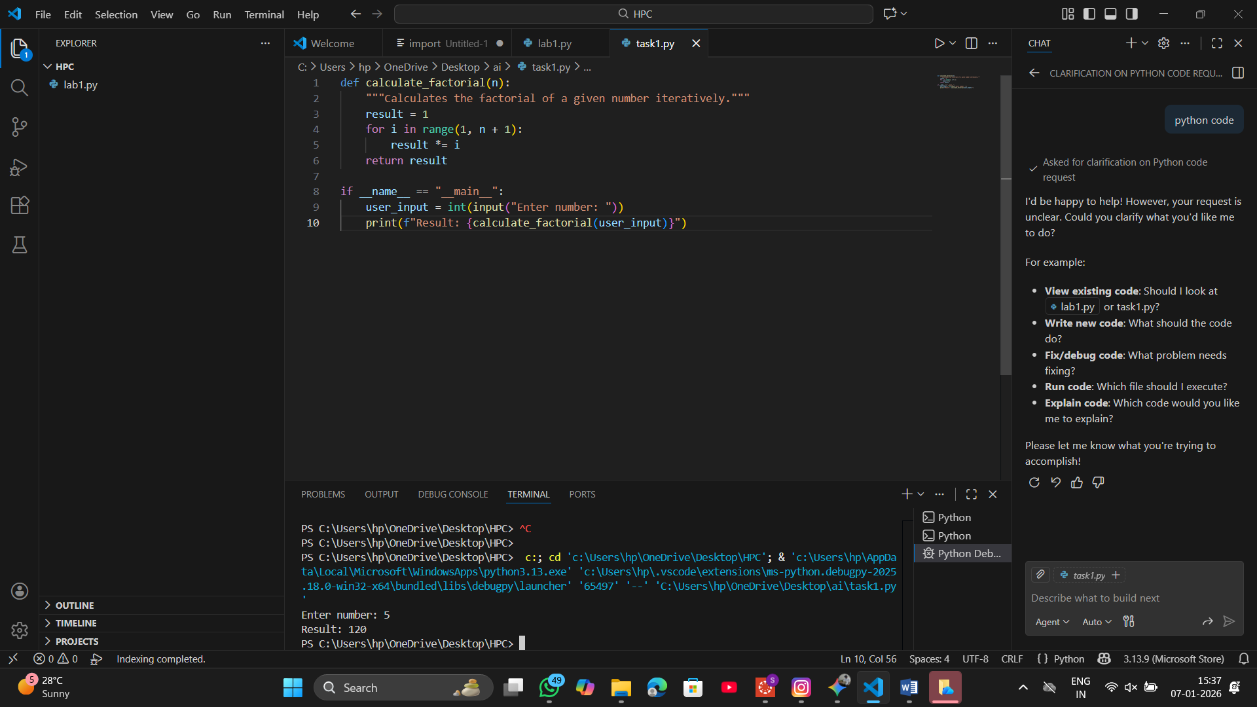
Task 4: Comparative Analysis:-
Comparative Analysis – Procedural vs Modular AI Code (With vs
Without Functions)
❖ Scenario
As part of a code review meeting, you are asked to justify design choices.
❖ Task Description
Compare the non-function and function-based Copilot-generated
programs on the following criteria:
➢ Logic clarity
➢ Reusability
➢ Debugging ease
➢ Suitability for large projects
➢ AI dependency risk
❖ Expected Deliverables
Choose one:
➢ A comparison table
OR
➢ A short technical report (300–400 words).
Criteria | Procedural (Task 1 & 2) | Modular (Task 3)
Logic Clarity | Linear and straightforward for very small tasks but becomes "spaghetti code" as complexity grows. | High clarity; the mathematical logic is isolated from the input/output logic.
Reusability | None. To use the logic elsewhere, the code must be manually copied and pasted. | High. The function can be imported into other Python files or called multiple times in one script.
Debugging Ease | Difficult. Errors in logic are mixed with errors in user input handling. | Simple. You can test the function with specific values (Unit Testing) to ensure the math is correct.
Project Suitability | Suitable only for small, one-off scripts or prototypes. | Essential for enterprise-level, large-scale software development.
AI Dependency Risk | High. AI might generate redundant variables or inefficient loops in long scripts. | Low. AI is highly specialized and accurate when asked to write specific, single-purpose functions.

Task 5: Iterative vs Recursive Thinking:-
: AI-Generated Iterative vs Recursive Thinking
❖ Scenario
Your mentor wants to test how well AI understands different
computational paradigms.
❖ Task Description
Prompt Copilot to generate:
An iterative version of the logic
A recursive version of the same logic
❖ Constraints
Both implementations must produce identical outputs
Students must not manually write the code first
❖ Expected Deliverables
Two AI-generated implementations
Execution flow explanation (in your own words)
Comparison covering:
➢ Readability
➢ Stack usage
➢ Performance implications
➢ When recursion is not recommended.
